ART PORTFOLIO

UI/UX Design Fundamentals - Christ University

**Submitted By:**

**Team Members:-**

**Full Name & Roll Number:**

Devika T.R & 2462064

Ashitha Vinod K & 2462048

Florentina Francis & 2462070

**College Email id:**

[devika.tr@btech.christuniversity.in](mailto:devika.tr@btech.christuniversity.in)

[ashitha.vinod@btech.christuniversity.in](mailto:ashitha.vinod@btech.christuniversity.in)

[florentina.francis@btech.christuniversity.in](mailto:florentina.francis@btech.christuniversity.in)

**Instructor Name:**

Ms. Nagaveena

**Index:**

* **Abstract**
* **Objectives**
* **Scope of the Project**
* **Tools & Technologies Used**
* **HTML Structure Overview**
* **CSS Styling Strategy**
* **Key Features**
* **Challenges Faced & Solutions**
* **Outcome**
* **Future Enhancements**
* **Sample Code**
* **Screenshots of Final Output**
* **Conclusion**
* **References**

**1. Abstract:**

This project presents a responsive and visually engaging online art portfolio designed for showcasing artwork in an interactive and organized manner. Using HTML for structure and CSS for styling, the portfolio features a dynamic gallery grid, smooth hover effects, and a lightbox viewing system. The layout is aesthetically appealing, mobile-friendly, and provides a professional platform for the artist to share work and connect with potential viewers or clients.

**2.Objectives:**

* To create a clean, responsive, and user-friendly art portfolio website.
* To showcase artworks in an organized, visually appealing grid format.
* To enable visitors to view enlarged versions of artworks using a lightbox feature.
* To provide a contact form for communication between the artist and visitors.
* To ensure compatibility across different devices and screen sizes.

**3. Scope of the Project:**

This portfolio is intended for artists, designers, and creative professionals to display their works online. The project covers:

* Responsive layout and design.
* Artwork grid display with hover animations.
* Lightbox functionality for detailed artwork viewing.
* A simple, functional contact form (front-end only).

**4. Tools & Technologies Used:**

* **HTML5** – for page structure and semantic elements.
* **CSS3** – for layout, styling, and responsive design.
* **Google Fonts (Poppins)** – for modern typography.
* **Gradient backgrounds & box-shadow** – for enhanced visual appeal.

**5. HTML Structure Overview:**

* **Header Section** – Introduces the artist with a title, image, and bio.
* **Gallery Section** – Displays images in a responsive grid layout.
* **Lightbox Elements** – Hidden divs that display enlarged images upon click.
* **Contact Section** – Includes a form with input fields for name, email, and message.

**6. CSS Styling Strategy:**

* Reset styles using margin: 0; padding: 0; box-sizing: border-box;.
* Header styling with gradient background and centered text.
* Gallery grid using CSS Grid with auto-fit for responsiveness.
* Hover effects to scale images and add shadows.
* Lightbox overlay with a semi-transparent background and centered image display.
* Contact form styled with padding, border radius, and color accents.

**7. Key Features:**

* Fully responsive design.
* Interactive gallery with hover animations.
* Lightbox functionality for larger artwork previews.
* Minimal, clean UI with professional typography.
* Contact form for visitor interaction**.**

**8. Challenges Faced & Solutions:**

* **Challenge:** Maintaining consistent image sizes in a responsive grid.  
  **Solution:** Used CSS Grid and minmax() to adapt sizes dynamically.
* **Challenge:** Creating a simple lightbox without JavaScript.  
  **Solution:** Used :target CSS selector to toggle lightbox visibility.

**9. Outcome:**

The final product is an aesthetically pleasing, responsive art portfolio website that effectively showcases the artist's work and enables audience engagement through the contact form.

**10. Future Enhancements**:

* . Adding JavaScript for advanced lightbox animations.
* Connecting the contact form to a backend service for email functionality.
* Adding categories and filters for artworks.
* Including captions or descriptions for each artwork.

**11.Sample Code:**

**This is a sample code not the actual code:-**

<!DOCTYPE html>

<html lang="en">

<head>

<meta charset="UTF-8">

<meta name="viewport" content="width=device-width, initial-scale=1.0">

<title>Mini Art Portfolio</title>

<link href="https://fonts.googleapis.com/css2?family=Poppins:wght@300;600&display=swap" rel="stylesheet">

<style>

body {

font-family: 'Poppins', sans-serif;

background: #f8f8f8;

color: #333;

margin: 0;

padding: 0;

}

header {

text-align: center;

padding: 2rem 1rem;

background: linear-gradient(135deg, #ffb347, #ffcc33);

color: white;

}

.gallery {

display: grid;

grid-template-columns: repeat(auto-fit, minmax(280px, 1fr));

gap: 1rem;

padding: 2rem;

}

.gallery img {

width: 100%;

border-radius: 10px;

box-shadow: 0 4px 10px rgba(0,0,0,0.1);

transition: transform 0.3s, box-shadow 0.3s;

}

.gallery img:hover {

transform: scale(1.05);

box-shadow: 0 8px 20px rgba(0,0,0,0.2);

}

</style>

</head>

<body>

<header>

<h1>My Art Portfolio</h1>

<p>Capturing emotions, colors, and stories through every stroke.</p>

</header>

<section class="gallery">

<img src="img1.jpg" alt="Artwork 1">

<img src="img2.jpg" alt="Artwork 2">

<img src="img3.jpg" alt="Artwork 3">

</section>

</body>

</html>

**12.Screenshots of Final Output**

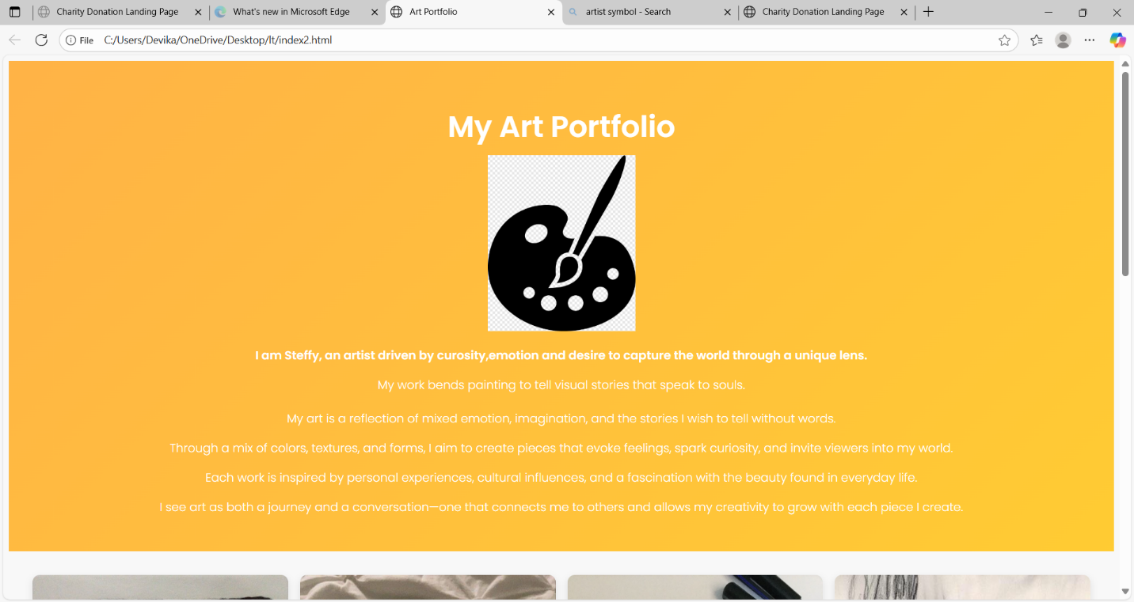

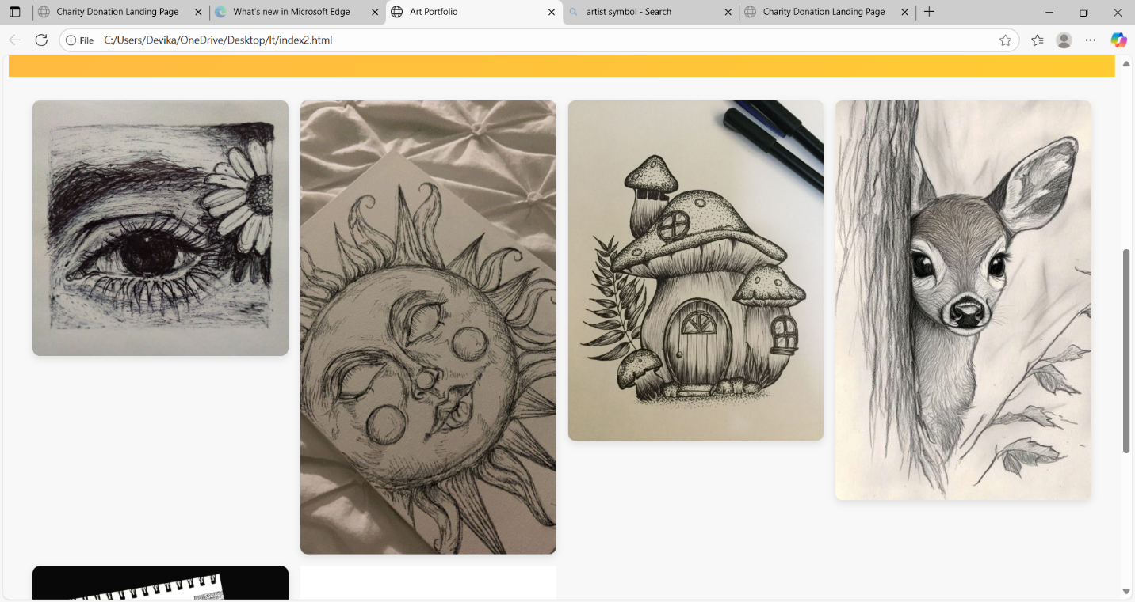

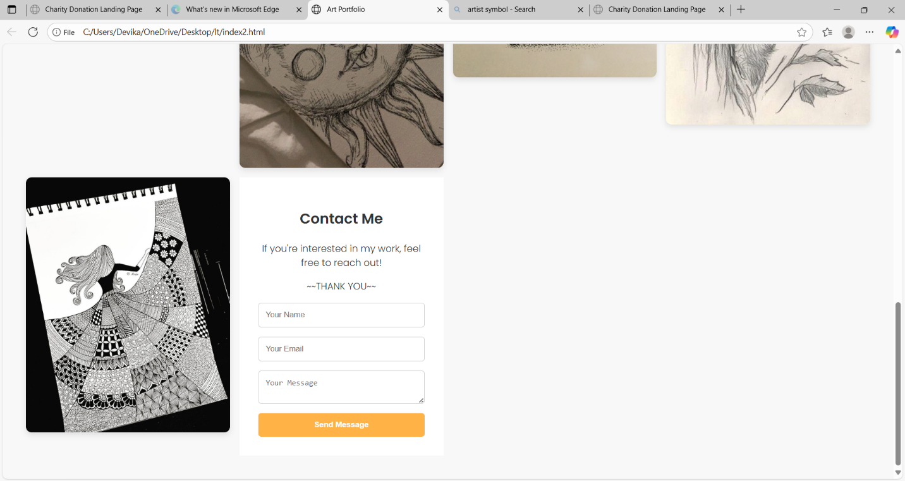

**13. Conclusion:**

This project successfully demonstrates how HTML and CSS can be used to build an elegant and functional portfolio website. It achieves the goal of showcasing artworks in an interactive, user-friendly manner, while maintaining visual balance and responsive adaptability. The design provides a strong foundation for future enhancements and additional features.

**14. References:**

**L&T LMS:**

https://learn.lntedutech.com/Landing/MyCourse